**PLEASE PRINT CLEARLY.** If you don’t settle your account at the auction, SFAS will mail a check to the address below. Seller (Consignor) is responsible for removing any unsold items from the meeting facility after the auction.

Name _______________________________________________________________ Member Code ____ ____ ____

Address______________________________________________________________ Check if NEW address _____

City _______________________________________________________ State __________ Zip ________________

Email ______________________________________________________ Phone _________________________________

| Bag # | Official Use Only | Description |  | Apply Received Stamp |
| --- | --- | --- | --- | --- |
| 1 |  |  |  | or write in the date. |
| 2 |  |  |  |  |
| 3 |  |  |  |  |
| 4 |  |  |  |  |
| 5 |  |  |  |  |
| 6 |  |  |  |  |
| 7 |  |  |  |  |
| 8 |  |  |  | Check-In is OK. |
| 9 |  |  |  | (Auction Co-Chair initials) |
| 10 |  |  |  |  |
| 11 |  |  |  | ________ |
| 12 |  |  |  |  |
| 13 |  |  |  |  |
| 14 |  |  |  |  |
| 15 |  |  |  |  |
| 16 |  |  |  | Apply **PAID** date stamp. |
| 17 |  |  |  |  |
| 18 |  |  |  |  |
| 19 |  |  |  |  |
| 20 |  |  |  |  |
| 21 |  |  |  | Seller received payment. |
| 22 |  |  |  | (Seller’s initials) |
| 23 |  |  |  |  |
| 24 |  |  |  | ________ |
| 25 |  |  |  |  |
|  | $ | Sales Total |  |  |
| **-** | $ | SFAS Commission (25%) |  |  |
| **=** | $ | Due to Seller |  | Auction Check-In Form, Rev 26.docx |

# **Instructions**

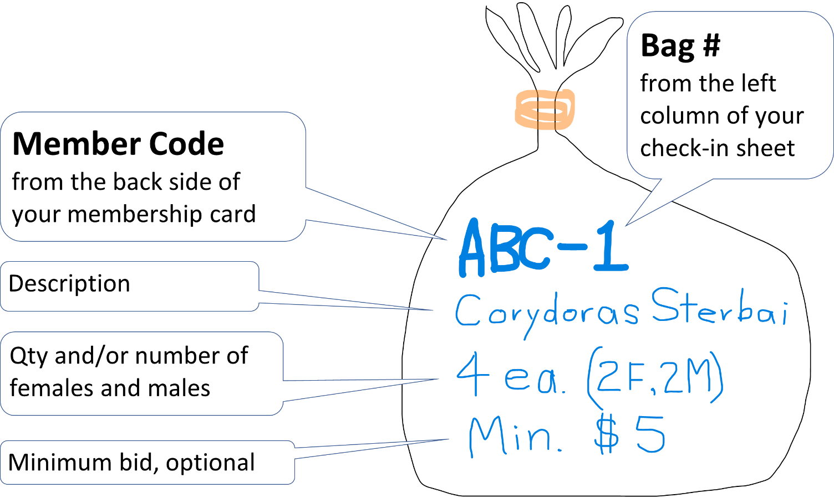

1. GENERAL
   1. Only current SFAS members may sell.
   2. SFAS facilitates auction transactions between buyer and seller are on a consignment basis. This means SFAS does not endorse merchandise, and does not assume any responsibility or liability for buyer satisfaction, merchandise condition or merchandise safety.
2. BEFORE YOU ARRIVE
   1. Please Prepare in Advance: Our good-hearted volunteers have limited time at the meeting to correct problems with bagging, labeling and check-in forms. So, please get your stuff ready, and get it correct, before you arrive.
   2. Check-In Sheet: Download and complete the latest Check-In Sheet from the Auction page of our website, SanFranciscoAquariumSociety.org. Be sure the **Member Code** and **Bag number** (for example **ABC-1**) on each of your bags matches the corresponding item pre-printed on your check-in sheet.
   3. Bag Live Goods: No leakers! Bag your plants and animals securely. Double-bag or use very sturdy bags. Beware that animal spines can puncture bags. Zip lock bags containing water are not allowed. Glass containers are not allowed. You may purchase spare bags and rubber bands at the Auction Check-in table if needed, subject to availability.
   4. Live Goods Label: Label your items as shown in the illustration above. Member Code, a hyphen, and the next sequential item number from your check-in sheet. Your Member Code is the three-letter code on the back of your membership card. These letters are NOT NECESSARILY your initials. Legible handwriting speeds the auction for everyone. So, take your time. Pretend your third-grade teacher is checking your penmanship!
   5. Hard goods Label: Label hard goods with your **Member Code** and **Item Number**, and with the condition of the merchandise (new/used, fully functional, needs repair, missing pieces, chemicals expired, etc.) Include specifics of any problem. The Auctioneer and buyers do not have time to determine the condition of your hard goods. NOTE WELL: Should the item condition labeling be absent or prove to be inconsistent with the actual condition of the item, then SFAS may share seller contact information with the buyer, charge the seller, or bar the seller from future auctions.
   6. Minimum Sale Price: You may establish a minimum price, but be careful. The minimum must be shown on the merchandise, not on the check-in sheet. SFAS will not sell for less than the minimum, and you will not be allowed to later reduce your minimum price if the item does not sell. Set a minimum only if you are prepared to take home unsold items after the auction.
   7. Maximum Number of Items: Sellers may bring a total of 25 items to each regular auction. This limit is waived for Mega Auctions. In either case, there is no limit on the number of identical items, subject to the maximum totals. However, Seller, beware that if you bring too many similar items the Auctioneer may exercise their options listed under “Slow” items.
   8. “Slow” Items: The Auctioneer is responsible for making money for the sellers and SFAS, keeping the crowd entertained, and finishing the auction on time. If similar items repeatedly sell for a very low price, or items fail to interest bidders, or the auction is behind schedule, then the Auctioneer may exercise the following options:
      1. Move items to the back of the queue where they usually sell for less or don’t sell at all.
      2. Bundle multiple items in a single bid.
      3. Sell similar items at the last sale price, without soliciting separate bids.
   9. Donated Items:
      1. Label donated items with the full word “DONATION” and the donor’s name. (Many donors are not members and have no Member Code.) Apply a yellow sticky dot to each item. Dots are available at the Check-in Table.
      2. If you require a receipt for your non-cash donation, then do not complete the Auction Check-in Form. Instead, complete the Donation Form, Non-Cash, which is downloadable from our website LINKS page. An SFAS officer must sign the completed form BEFORE such donations can be accepted. Donated labeling requirements apply.
      3. The other rules for live and hard goods apply also to donations.
3. CHECK-IN
4. Schedule: Auction Check-in is from 6:30 PM to 7:00 PM. If you come later, you may check in during our 10-minute break, which happens sometime after 8:00 PM. Please respect the other attendees, and bring your stuff on time. Late arrivals interrupt the meeting, and may go to “the back of the line” where they may no be sold.
5. Check-in: Place your items on the CHECK-IN TABLE and present your already-completed Check-In Form to the attendant. If all is OK, the attendant will move your items to the correct AUCTION TABLE. The auction staff has its methods, so please do not place your own merchandise on the Auction Tables.
6. Have a seat and enjoy the show!
7. CHECK-OUT
   1. Item Removal: Once an item is checked in, the seller/donor may not remove it unless it is unsold at the auction end.
   2. Unsold Items: There may be situations when the number of submitted items exceeds what we can sell during the auction. It is the owner’s responsibility to remove unsold items. If the owner does not take the items, SFAS will dispose of the items on a best effort basis, including giving them away free.
   3. Splits: The seller receives 75% of the auction sale price, and SFAS receives 25%.
8. Errors: We make mistakes, but we double check our receipts vs. tabulations after the auction. If a Seller accepted their cash payment at the auction, then we will correct an error only if it exceeds $5 in our favor, or $40 in the Seller’s favor.